Project Design Phase-II
Technology Stack (Architecture & Stack)

Date | 15 Feb 2026
Team ID | LTVIP2026TMIDS88736
Project Name | Exploratory Analysis of Rainfall Data in India for Agriculture
Maximum Marks | 4 Marks

Technical Architecture:
The deliverable shall include the architectural diagram as shown below, along with detailed information provided in Table 1 and Table 2.
Example: Order processing during pandemics for offline mode
Guidelines:
Include all the processes as application logic or technology blocks, as shown in the architectural diagram.
Clearly demarcate the infrastructure components (Local environment / Cloud environment).
Indicate all external interfaces such as third-party APIs or external services.
Specify the data storage components or services used in the system.
Clearly show the interface or integration with machine learning models, if applicable.

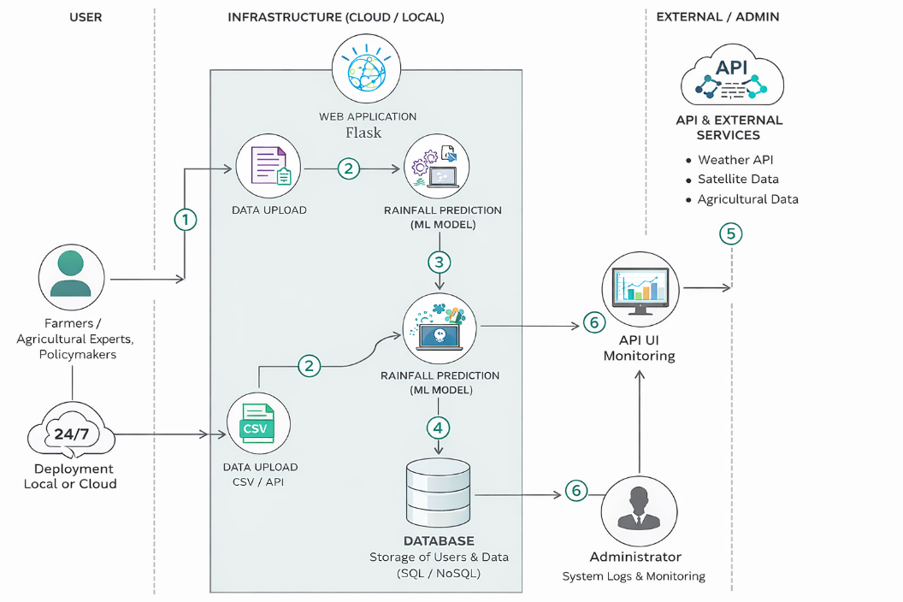

Table-1 : Components & Technologies:
S.No | Component | Description | Technology
 | User Interface | Interface through which farmers, experts, and policymakers interact with the system (Web Dashboard for upload, visualization & reports) | HTML, CSS, JavaScript, Bootstrap
 | Application Logic-1 | Backend logic for data upload, validation, and preprocessing | Python (Flask, Pandas, NumPy)
 | Application Logic-2 | Data analysis and visualization logic for rainfall trends | Matplotlib, Seaborn
 | Application Logic-3 | Machine learning logic for rainfall prediction and drought/flood classification | Scikit-learn (Random Forest, Decision Tree, Regression Models)
 | Database | Storage of user credentials, rainfall datasets, and prediction results | MySQL / SQLite
 | Cloud Database | Cloud-based storage for scalable deployment | MongoDB Atlas / IBM Cloudant
 | File Storage | Storage of uploaded CSV rainfall datasets and generated reports | Local File System / Cloud Storage
 | External API-1 | Fetch real-time weather or rainfall data | Weather API (e.g., OpenWeather API)
 | External API-2 | Agricultural datasets integration (optional) | Government Open Data API
 | Machine Learning Model | Predict rainfall patterns, drought risk, and crop suitability | Random Forest, Linear Regression, XGBoost
 | Infrastructure (Server / Cloud) | Deployment of application on local server or cloud environment | Localhost / AWS / IBM Cloud / Azure

Table-2: Application Characteristics:
S.No | Characteristics | Description | Technology
 | Open-Source Frameworks | Open-source tools and libraries used in the application | Flask, Pandas, NumPy, Scikit-learn, Matplotlibof Opensource framework
 | Security Implementations | Secure login, password hashing, data encryption, access control | SHA-256, HTTPS, Role-Based Access Control
 | Scalable Architecture | System designed to handle increasing data and users (3-tier architecture: UI, Logic, Database) | Flask Backend + SQL/NoSQL DB + Cloud Deployment
 | Availability | Ensures application uptime with minimal downtime | Cloud Hosting, Backup & Monitoring
 | Performance | Optimized for fast data processing and prediction; handles moderate datasets efficiently | Efficient Pandas processing, Indexed Database, Caching

